Ideation Phase
Brainstorm & Idea Prioritization Template

Date | 31 January 2025
Team ID | LTVIP2026TMIDS34879
Project Name | Online Payments Fraud Detection Using Machine Learning
Maximum Marks | 4 Marks

Brainstorm & Idea Prioritization Template:
Brainstorming provides a free and open environment that encourages everyone within a team to participate in the creative thinking process that leads to problem solving. Prioritizing volume over value, out-of-the-box ideas are welcome and built upon, and all participants are encouraged to collaborate, helping each other develop a rich number of creative solutions.
Step-1: Team Gathering, Collaboration and Select the Problem Statement
Team Members:
Team Leader: Vaishnavi Sravanthi P
Team Member: Batti Yasmin
Team Member: K Hema Madhuri
Discussion Summary
- Discussed increasing fraud in digital payment systems
- Identified challenges in detecting real-time fraudulent transactions
- Reviewed existing systems (rule-based detection limitations)

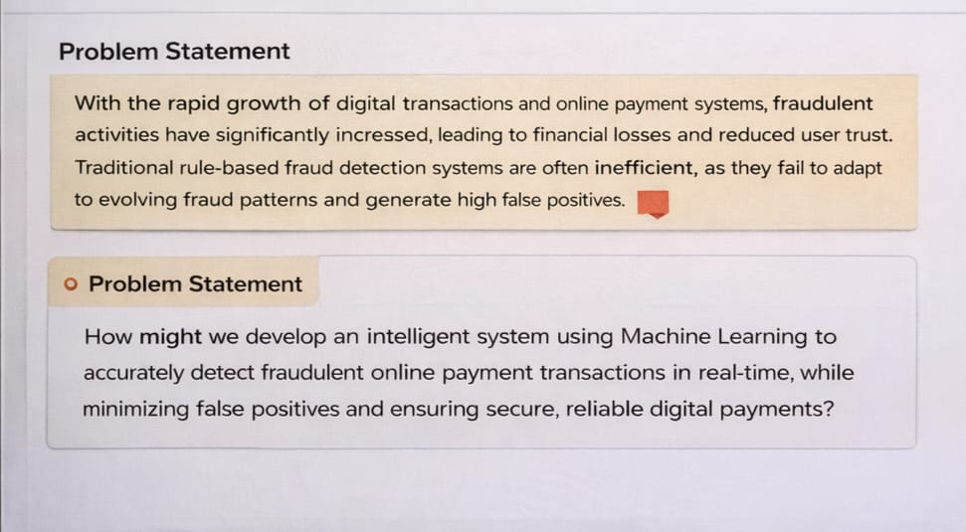

Step-2: Brainstorm, Idea Listing and Grouping
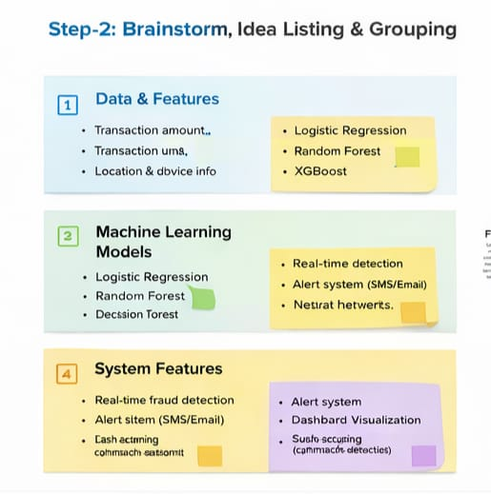

Step-3: Idea Prioritization
